* 1. Introduction:

In this document, we will introduce the analytical study of the service using the needed UML diagrams for system requirements modeling.

* 1. Detailed Service Requirements:

Table 5 base management service detailed requirements

|  |  |  |  |
| --- | --- | --- | --- |
| **Req_ID** | **Requirement Title** | **category** | **description** |
| RE-FR-AM-01 | The system should provide organization managers the ability to create a new account, using their credentials as the first step of the registration flow | account management | The credentials needed are only email + a strong password (according to the system password limits), full name, and birthdate. |
| RE-FR-AM-02 | The system should be able to verify users’ emails by using a verification code "OTP" as the second step of the registration flow. | account management | The OTP is a random 5-digit number. |
| RE-FR-OM-03 | The system should provide organization managers with the ability to register their organization in the system as the third step of the registration flow. | Organization management |  |
| RE-FR-AM-04 | The system should allow all users to log in to their accounts using their credentials | account management | email + password |
| RE-FR-AM-05 | The system should allow users to view their account information | account management | basic information like "username", photo, email… |
| RE-FR-AM-06 | The system should provide users the ability to update their account information. | account management |  |
| RE-FR-OM-07 | The system should provide the organization manager the ability to create a new organization member account. | Organization  management | Email, default password. |
| RE-FR-OM-08 | The system should provide the organization manager the ability to add a member to the organization. | Organization  management |  |
| RE-FR-AM-09 | The system should force the newly created members to complete their account missing information. | account management |  |
| RE-FR-AM-10 | The system should ask new members with default passwords to change the password, to a strong password that follows the system requirements. | Account management |  |
| RE-FR-OM-11 | The system should provide organization managers with the ability to deactivate Organization members' accounts. | Organization  management |  |
| RE-FR-OM-12 | The system should allow the organization manager or a member with the right privileges to assign privileges to team members. | Organization management. | The system defines fixed privileges, read/write on every aspect of the project. |
| RE-FR-OM-13 | The system should allow the organization manager or to make a member as admin. |  | The admin full access privileges over the organization. |
| RE-FR-OM-14 | The system should allow the organization manager or a member with the right privileges to remove a privilege from a team member. | Organization management |  |
| RE-FR-OM-15 | The system should be able to show each organization member with their related privileges. | Organization management. |  |
| RE-FR-PM-16 | The system should provide the organization manager or a member with the right privileges the ability to create a new project. | project  management |  |
| RE-FR-PM-17 | The system should provide the organization manager or a member with the right privileges the ability to deactivate a project. | Project  management |  |
| RE-FR-PM-18 | The system should be able to display all projects related to an organization. | Project  management |  |
| RE-FR-PM-19 | The system should provide the organization manager or a member with the right privileges the ability to assign a member to a project. | Project  management |  |
| RE-FR-PM-20 | The system should provide an org manager with the right privileges to remove a member from a project. | Project  management |  |
| RE-FR-PM-21 | The system should be able to view all the members related to a specific project. | Project  management |  |
| RE-FR-RM-22 | The system should provide project managers with the ability to add project requirements manually. | Requirements management |  |
| RE-FR-RM-23 | The system should provide project managers the ability to add project requirements by uploading files. | Requirements management | The system supports CSV,21111 and Excel files. |
| RE-FR-RM-24 | The system should be able to display the project requirements Backlog. | Requirements management |  |
| RE-FR-RM-25 | The system should provide the ability to update a project requirement. | Requirements management |  |
| RE-FR-RM-26 | The system should provide the ability to delete a project requirement from the requirement list. | Requirements management |  |
| RE-FR-OM-27 | The system should provide the organization manager with statistical insights to describe the organization's status effectively. | Organization management | Active projects no. , inactive projects no. , members no. |
| RE-NF-28 | The system should respond to any action in less than 3 sec. | Nonfunctional requirements | Performance |
| RE-NF-29 | The system should provide strong authentication ways using access and refresh tokens to provide security. | Nonfunctional requirements | Security |
| RE-NF-30 | The system should handle privileges and access control to apply security. | Nonfunctional requirements | Security |
| RE-NF-31 | The system should provide easy-to-use interfaces for users, Users need on average “10 min” to completely navigate and understand all the parts and pages of the system. | Nonfunctional requirements | Usability. |

* 1. Requirements Modeling:

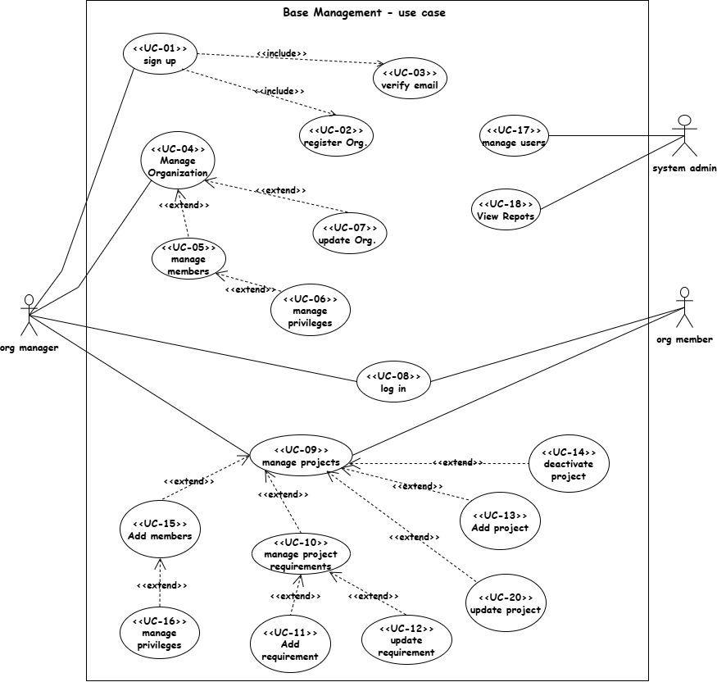Use case diagram:

Figure 4 use case diagram

service features – Sign-up flow UC-01:

Table 6 sign-up flow specification

|  |  |
| --- | --- |
| Use case name: | Sign-Up |
| Participating Actors: | Initiated by: organization manager |
| The flow of events: | 1. The organization manager enters the website on the sign-up page. 2. The system shows the first form for the base account data. 3. The Org manager completes the form and chooses “create account”. 4. The system applies verification over the form fields 5. The system will send to the Org. manager an OTP via email to verify it. 6. The Org. manager enters the received OTP. 7. The system checks the entered OTP. 8. The system routes the organization manager to the third form page to register their organization. 9. The Org. manager completes the fields needed. 10. The system applies verification over the form fields. 11. The system creates and saves the new account and organization data and routes the Org. manager to the main page in the system. |
| Alternative flows: | First alternative flow A1: start at step 4 or 10 in the main flow, there is a missing field: 5. the system will show an error message “There is a missing field”.  6. the Org. manager will complete the fields and the flow will return to step 3.  Second alternative flow A2: start at step 4 from the alternative flow: the email already exists.   1. The system will ask the Org. manager to choose another email. 2. The Org manager will reenter the email field, and the flow will return to step 4.   Third alternative flow A3: if the password the Org. manager chose is weak start at 4:   1. The system will tell the Org. manager owner that the password must be at least 8 characters. 2. The Org. manager will reenter the password, and the flow will return to step   Fourth alternative flow A4: if the OTP is incorrect start at step 7 in the main flow:  5. the system will show an error message “incorrect OTP “.  6. the Org. manager will choose “resend OTP”.  And the flow will return to step 6.  First exception flow E1: if the verify code is incorrect the system will cancel the whole process, and the use case will fail. |
| Entry condition | The user opens the system website. |
| Exit conditions | The Org. manager has an account, organization is registered |

Activity diagram:

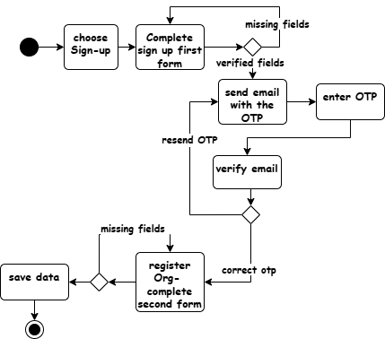

Figure 5 sign-up flow

Sequence diagram:

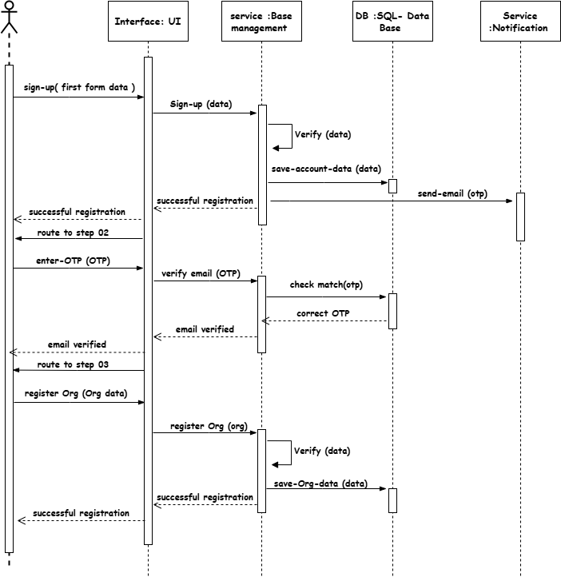

Figure 6 Sign-up sequence diagram

service features – manage members UC-05:

Table 7 manage members specification

|  |  |
| --- | --- |
| Use case name: | Manage members |
| Participating Actors: | Initiated by: organization manager or any organization member with the right privileges (admin). |
| The flow of events: | 1. When the organization manager chooses to add a new Org. member. 2. The system shows the “add new member” form. 3. The Org. manager enters the email for the new member. 4. The system will verify the entered email. 5. The system will generate a default password for the new account created. 6. The system sends emails to notify the members of the account creation with the password generated. 7. The organization member logs in to the system, with their default credentials. 8. The system shows the complete account form. 9. The organization member completes the account missing data and changes the password. 10. The system makes the members an active Org. member. 11. If the organization manager chooses to manage the member privileges. 12. The system shows all organization members. 13. The org. manager chooses to make a member as an Org. admin. 14. The system gives the admin privilege to the org. member. |
| Alternative flows: | First exception flow E1: start at step 4 from the alternative flow: the email already exists.   1. The system will show an error message for this member and the use case will fail. |
| Entry condition | The user has the right privileges. |
| Exit conditions | A New Org member account was created. |

Sequence diagram:

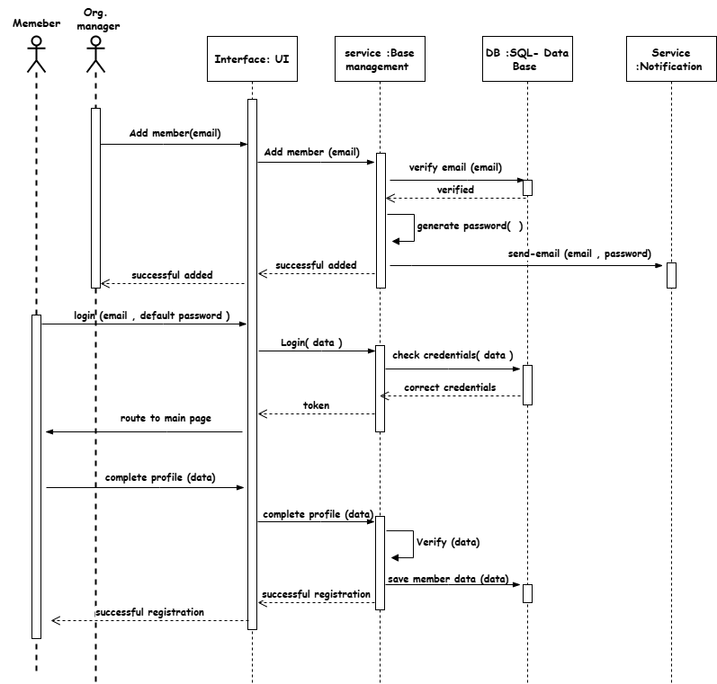

Figure 7 manage member sequence diagram

Activity diagram: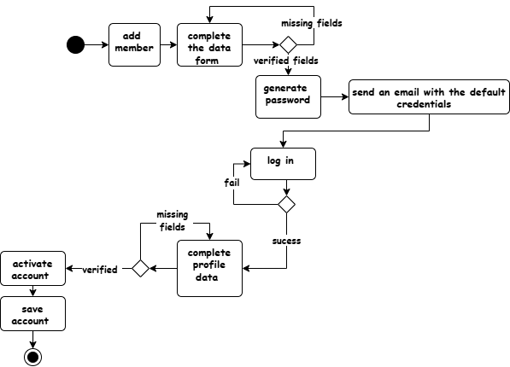

Figure 8 manage member activity diagram

service features – manage projects UC-09:

Table 8 manage projects specification

|  |  |
| --- | --- |
| Use case name: | Manage projects |
| Participating Actors: | Initiated by: organization manager or any organization member with the right privileges (admin). |
| The flow of events: | 1. When the user enters the “projects” interface. 2. The system shows the Org. existing project active and inactive ones. 3. If the user asks to add a new project:    1. The system shows the “add project” form    2. The user enters the project information needed and completes the form.    3. The user adds an organization member as a project manager.    4. The system verifies the information entered.    5. The system creates the new project and saves it to the database.    6. The system gives the project manager member full access privileges over this project 4. If the user asks to deactivate a project:    1. The system asks to select a project.    2. The user selects a project    3. The system deactivates the selected project. 5. If the user asks to update project information:    1. The system shows the old information form.    2. The user updates the needed fields.    3. The system verifies and updates the project information and saves it. |
| Alternative flows: | First alternative flow A1: start at step 7 from the alternative flow: “missing data”   1. The system shows an error message of missing data.   And the flow returns to step 5. |
| Entry condition | The user has the right privileges. |
| Exit conditions | A new project was created. |

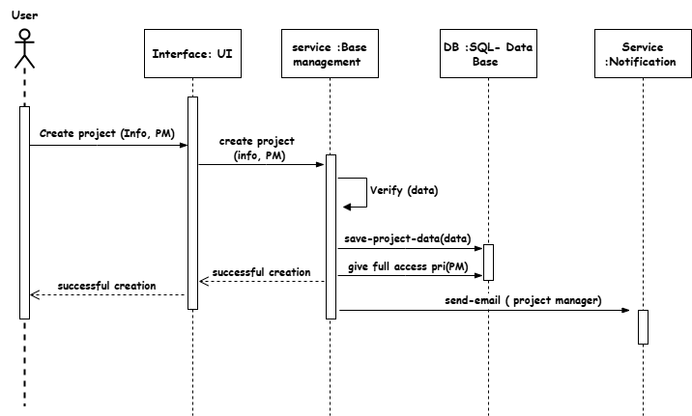Sequence diagram – create project:

Figure 9 create project sequence diagram

Sequence diagram – update project:

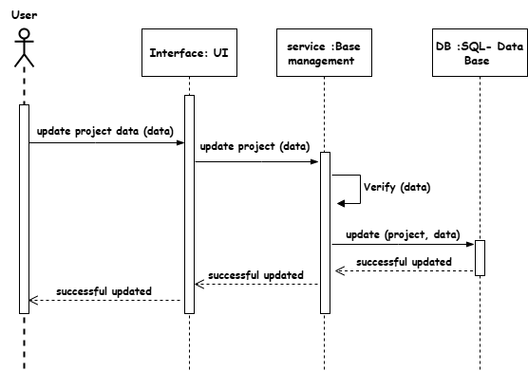

Figure 10 update project sequence diagram

service features – manage project requirements UC-10:

Table 9 manage project requirements specification

|  |  |
| --- | --- |
| Use case name: | Manage project requirements |
| Participating Actors: | Initiated by: organization manager or any organization member with the right privileges. |
| The flow of events: | 1. If the user chooses to manage requirements. 2. The system will open the requirements management interface and display the req backlog for this project. 3. If the user asks to “add a new requirement” to the table manually: 4. The system will give a new empty row on the req. table and ask the user to enter information to complete the row. 5. The user will enter the req.id, req. title, req. priority. 6. The system will add the new req to the req table and display it to the user. 7. If the user asks to add the requirements from a file.    1. The system shows the file uploading interface with the related instructions.    2. The user will upload a local file.    3. The system will parse and extract requirements from the file and add it to the project backlog. 8. If the user, asks to “delete a specific req”. 9. The system will ask to confirm the process. 10. The user will confirm the process. 11. The system will delete the req from the table and display the edited table to the user. 12. If the user, asks to “edit a specific requirement information”. 13. The system asks to enter new information about the requirement. 14. The user will enter the information needed. 15. The system will edit the req. info and display it to the user. |
| Entry condition | The user has the right privileges. |
| Exit conditions | A new project was created. |

Sequence diagram:

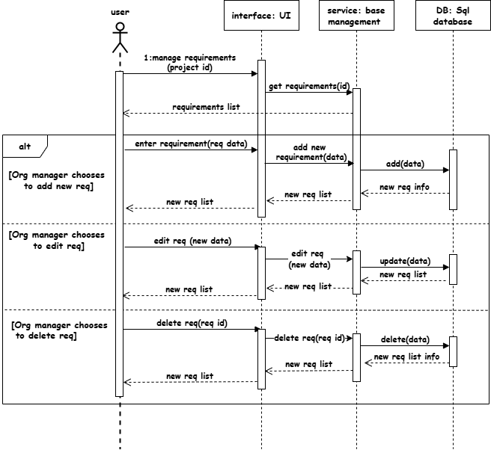

Figure 11 requirements management sequence diagram

service features – manage members' privileges UC-16:

|  |  |
| --- | --- |
| Use case name: | Manage members privileges |
| Participating Actors: | Initiated by: organization manager or any organization member with the right privileges. |
| The flow of events: | 1. When the user chooses to assign a member to a project. 2. The system shows the existing members of the organization. 3. The user chooses a member to assign to this project. 4. The system assigns the member to the project and gives them the default privileges (read for (meetings, members, requirements, none for settings). 5. If the user chooses to edit the privileges 6. The user will choose the new privilege over each section (members, meetings, requirements, settings). 7. The system will update the privileges of the member. 8. The system will save changes. 9. The system notifies the member about the changes |
| Entry condition | The user has the right privileges. |
| Exit conditions | Member privilege managed. |

Sequence diagram:

Figure 12 manage privileges sequence diagram

ERD Diagram:

Figure 13 entity relationship diagram

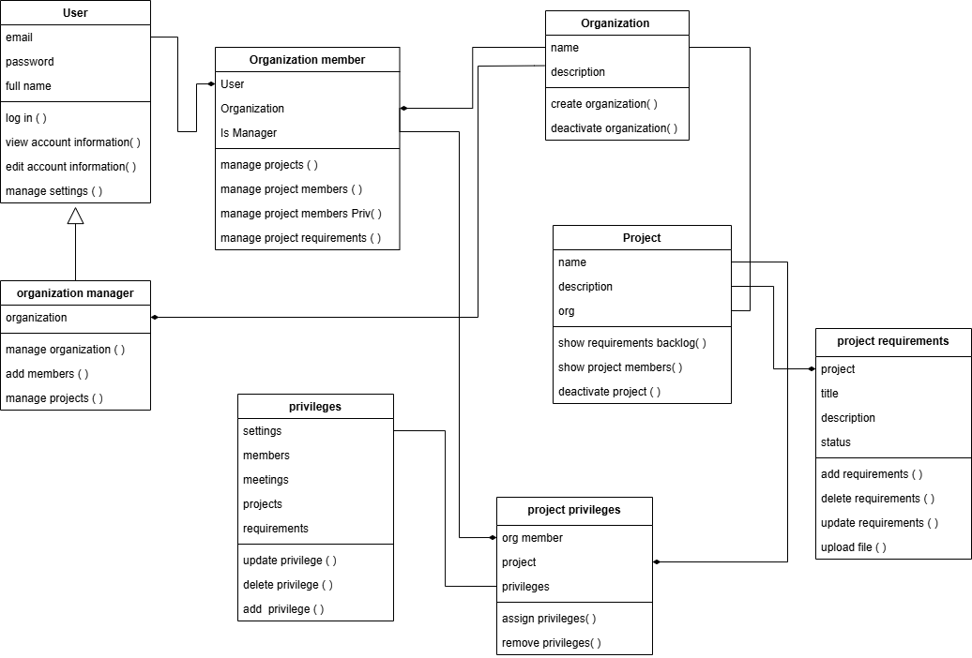Class diagram: